***Solution Section* 1.1 – Velocity and Net Change**

***Exercise***

Assume *t* is time measured in seconds and velocities have units of *m/s*. 

1. Graph the velocity function over the given interval. Then determine when the motion is in the positive direction.
2. Find the displacement over the given interval.
3. Find the distance traveled over the given interval.

***Solution***

1. The motion is positive for  and negative for 
2. 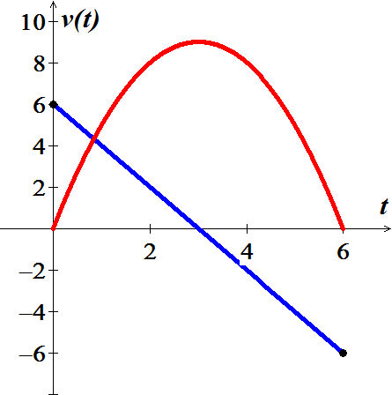Displacement 



 

1. Distance traveled is 







***Exercise***

Assume *t* is time measured in seconds and velocities have units of *m/s*. 

1. Graph the velocity function over the given interval. Then determine when the motion is in the positive direction.
2. Find the displacement over the given interval.
3. 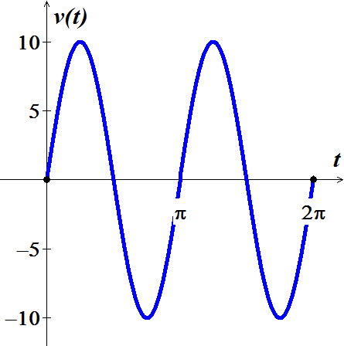Find the distance traveled over the given interval.

***Solution***

1. The motion is positive for 

and negative for 

1. Displacement 





1. Distance traveled is 







***Exercise***

Assume *t* is time measured in seconds and velocities have units of *m/s*. 

1. Graph the velocity function over the given interval. Then determine when the motion is in the positive direction.
2. Find the displacement over the given interval.
3. Find the distance traveled over the given interval.

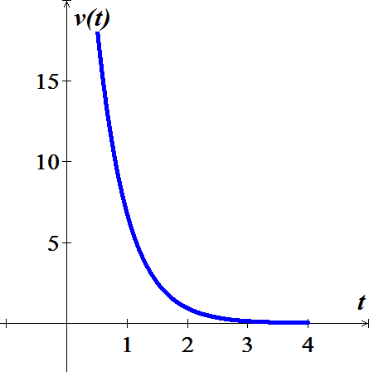***Solution***

1. The motion is positive for 
2. Displacement 







1. Distance traveled is the same displacement si 

***Exercise***

Consider an object moving along a line with the following velocities and initial positions



1. Graph the velocity function on the given interval. Then determine when the object is moving in the positive direction and when it is moving in the negative direction.
2. Determine the position function for  using both the antiderivative method and the Fundamental Theorem of Calculus. Check for agreement between the two methods.
3. Graph the position function on the given interval.

***Solution***

1. The motion is positive for  and negative for 
2. 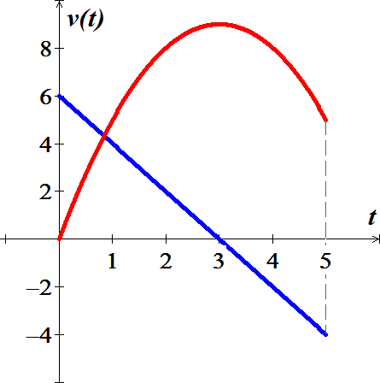

***Given***: 



Also, 





***Exercise***

Consider an object moving along a line with the following velocities and initial positions



1. Graph the velocity function on the given interval. Then determine when the object is moving in the positive direction and when it is moving in the negative direction.
2. Determine the position function for  using both the antiderivative method and the Fundamental Theorem of Calculus. Check for agreement between the two methods.
3. Graph the position function on the given interval.

***Solution***

1. The motion is positive for  and negative for 
2. 

***Given***: 



Also, 





***Exercise***

Find the position and velocity of an object moving along a straight line with the given acceleration, initial velocity, ansd initial position. Assume units of meters and seconds.



***Solution***



Since 







Since 



***Exercise***

Find the position and velocity of an object moving along a straight line with the given acceleration, initial velocity, ansd initial position. Assume units of meters and seconds.



***Solution***



Since 







Since 



***Exercise***

A mass hanging from a spring is set in motion and its ensuing velocity is given by  for . Assume that the position direction is upward and .

1. Determine the position function for .
2. Graph the position function on the interval [0, 3].
3. At what times does the mass reach its lowest point the first three times?
4. At what times does the mass reach its highest point the first three times?

***Solution***

1. 





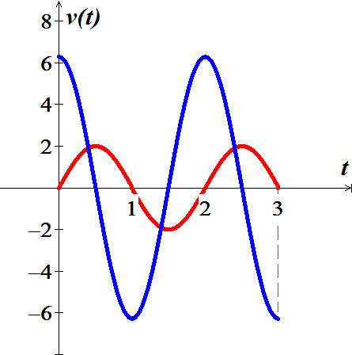

1. The smallest value of Sine is , therefore the angle are



The mass reaches its lowest point at 

1. The Largest value of Sine is 1, therefore the angle are



The mass reaches its highest point at 

***Exercise***

The velocity of an airplane flying into a headwind is given by  *mi/hr* for . Assume that 

1. Determine and graph the position function for .
2. How far does the airplane travel in the first 2 *hr*.?
3. How far has the airplane traveled at the instant its velocity reaches 400 *mi/hr*.?

***Solution***

1. 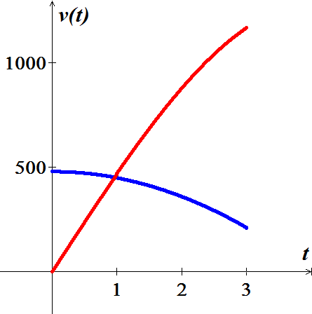 





1. 
2. ***Given***: ; 





***Exercise***

A car slows down with an acceleration of . Assume that  and 

1. Determine and graph the position function for .
2. How far does the car travel in the time it takes to come to rest?

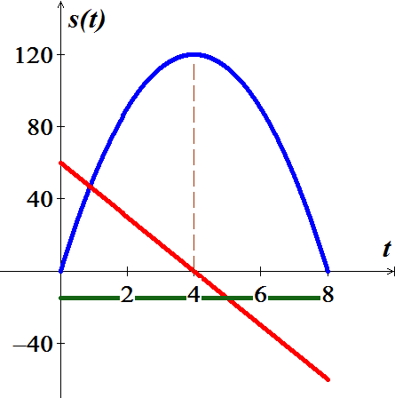***Solution***

1. 

***Given***: 





 

***Given***: 



1. The car comes to rest when 



***Exercise***

The owners of an oil reserve begin extracting oil at . Based on estimates of the reserves, suppose the projected extraction rate is given by , where , *Q* is measured in millions of barrels, and *t* is measured in years.

1. When does the peak extraction rate occur?
2. How much oil is extracted in the first 10, 20, and 30 years?
3. What is the total amount of oil extracted in 40 year?
4. Is one-fourth of the total oil extracted in the first one-fourth of the extraction period? Explain.

***Solution***

|  |  |
| --- | --- |
| **0 20 40** | |
| **+** | **−** |

1. 





From the table,  is maximized at ; therefore the peak extraction rate is at 

1. In the first **10 years**:









 1,060,000 millions of barrels

In the first **20** years











 *millions* of barrels

In the first **30** years











 *millions* of barrels

1. Total amount of oil extracted in 40 year











 *millions* of barrels

1. 

No, the amount extracted in the first 10 years is not  of the total amount extracted.

***Exercise***

Starting with an initial value of , the population of a prairie dog community grows at a rate of  (in units of prairie *dogs/month*), for 

1. What is the population 6 months later?
2. Find the population  for 

***Solution***

1. 







1. 





***Exercise***

The population of a community of foxes is observed to fluctuate on a 10-year cycle due to variations in the availability of prey. When population measurements began (*t* = 0 years), the population was 35 foxes. The growth rate in units of *foxes/yr*. was observed to be



1. What is the population 15 years later? 35 years later?
2. Find the population  at any time 

***Solution***

1. 













1. 





***Exercise***

A strong west wind blows across a circular running track. Abe and Bess start at the south end of the track and at the same time, Abe starts running clockwise and Bess starts running counterclockwise. Abe runs with a speed (in units of *mi/hr*.) given by  and Bess runs with a speed given by , where *φ* and *θ* are the central angles of the runners

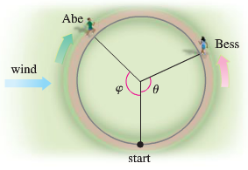

1. Graph the speed functions *u* and *v*, and explain why they describe the runners’ speed (in light of the wind).
2. Which runner has the greater average speed for one lap?
3. If the track has a radius of  , how long does it take each runner to complete one lap and who wins the race?

***Solution***

1. 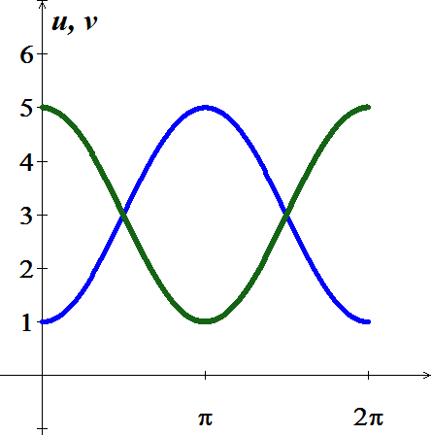Abe starts out running into a headwind

Bess starts out running with a tailwind.

1. Abe’s average speed 



 

Bess’ average speed 





They have the same average speed.

1. The track is  in radius ⇒ 

We have 



|  |  |
| --- | --- |
| Abe’s time:          Bess’ time: | Let |

They tie the race, both have average speed 

***Exercise***

A reservoir with a capacity of 2500  is filled with a single inflow pipe. The reservoir is empty and the inflow pipe is opened at *t* = 0. Letting  be the amount of water in the reservoir at time *t*, the flow rate of water into reservoir (in ) oscillates on 24-*hr* cycle and is given by



|  |
| --- |
| Flow rate of water (m3/hr.) |

1. How much water flows into the reservoir in the first 2 *hr*s.?
2. Find and graph the function that gives the amount of water in the reservoir over the interval  where .
3. 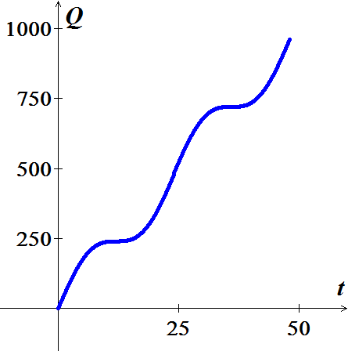When is the reservoir full?

***Solution***

1. 





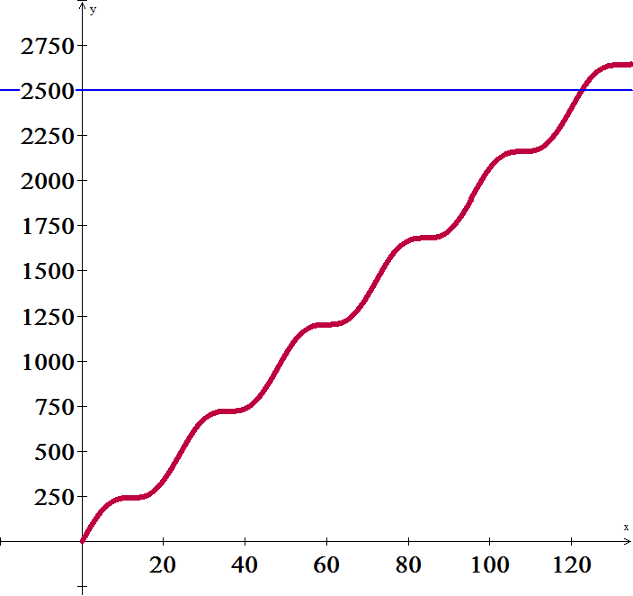 

1. 





1. The reservoir is full when 

Using program: 

***Exercise***

The velocity of an object moving along a line is given by . What is the displacement of the object after 1.5 *sec*?

***Solution***









***Exercise***

A projectile is launched vertically from the ground at , and its velocity in flight (in *m/s*) is given by . Find the position, displacement, and distance traveled after *t* seconds, for 

***Solution***

Position = Displacement











Distance for  is









***Exercise***

At , a car begins decelerating from a velocity of 80 *ft/s* at a constant rate of . Find its position function assuming .

***Solution***

***Given***: 

















***Exercise***

The acceleration of an object moving along a line is given by . The initial velocity and position are  and 

1. Find the velocity and position for 
2. What are the minimum and maximum values of *s*?
3. Find the average velocity and average position over the interval 

***Solution***

***Given***: 

1. 

















1.  



At   has a *minimum* of 

At   has a *maximum* of 

1. *Average velocity* 





*Average position* 







***Exercise***

Starting at the same point on a straight road, Anna and Benny begin running with velocities (in *mi/hr*) given by  and , respectively.

1. Graph the velocity functions, for .
2. If the runners run for 1 *hr*, who runs farther? Interpret your conclusion geometrically using the graph in part (*a*).
3. If the runners run for 6 *mi* who wins the race? Interpret your conclusion geometrically using the graph in part (*a*).

***Solution***

1. 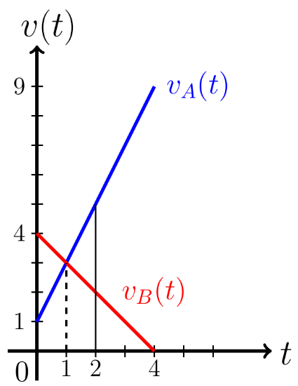 

|  |  |  |
| --- | --- | --- |
|  |  |  |
| 0 | 1 | 4 |
| 4 | 9 | 0 |

1. 













∴ The area *Anna* under graph from 0 to 1 is smaller than the area under *Benny*’s graph.

1. 







At , both velocity function have the same area under them = **6** *miles*.

***Exercise***

A small plane in flight consumes fuel at a rate (in *gal/min*) given by



1. Find a function *R* that gives the total fuel consumed, for 
2. Find a function *R* that gives the total fuel consumed, for 
3. If the fuel tank capacity is 150 *gal*, when does the fuel run out?

***Solution***

1. For 







1. 















∴ 

1. ***Given***: 







∴ The fuel run out in **59** *minutes*.

***Exercise***

Water flows out of a tank at a rate  given by . If the tank initially holds 75  of water, when will the tank be empty?

***Solution***

***Given***:  



















 (*too large*)



***Exercise***

A projectile is fired upward, and its velocity in *m/s* is given by .

1. Graph the velocity function, for .
2. When does the velocity reach 50 *m/s*?
3. Find and graph the position function for the projectile for , assuming .
4. Given unlimited time, can the projectile travel 2500 *m*? If so, at what time does the distance traveled equal 2500 *m*?

***Solution***

1. ***Given***: 

|  |  |
| --- | --- |
|  |  |
| 0 | 200 |
| 10 |  |

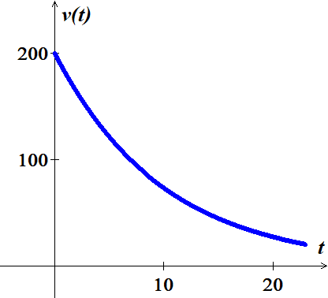

1. 



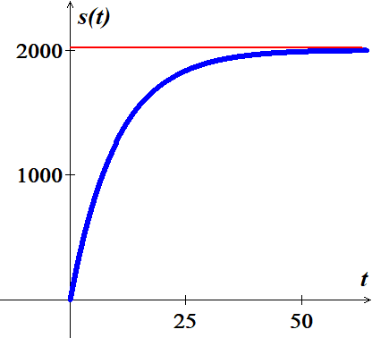



1. 









1. 



The projectile ***cannot*** travel 2500 *m*

***Exercise***

A projectile is fired upward, and its velocity in *m/s* is given by .

1. Graph the velocity function, for .
2. Find and graph the position function for the projectile for , assuming .
3. Given unlimited time, can the projectile travel 2500 *m*? If so, at what time does the distance traveled equal 2500 *m*?

***Solution***

1. ***Given***: 

|  |  |
| --- | --- |
|  |  |
| 0 | 200 |
| 3 |  |
| 9 | 20 |

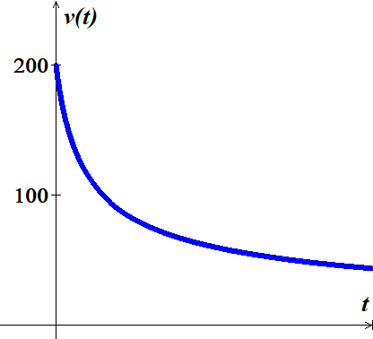

1. 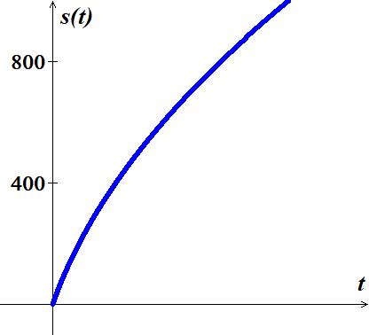





|  |  |
| --- | --- |
|  |  |
| 0 | 0 |
| 3 | 400 |

1. From the graph, the projectile will travel 2500 *m*













***Exercise***

Jeff and Mel took a bike ride, both starting at the same time and position. Jeff started riding at 20 *mi/hr*, and his velocity decreased according to the function . Mel started riding at 15 *mi/hr*, and her velocity decreased according to the function 

1. Find and graph the positions of Jeff and Mel.
2. Find the times at which the riders have the same position at the same time.
3. Who ultimate took the lead and remained in the lead?

***Solution***

1. ***Given***: 





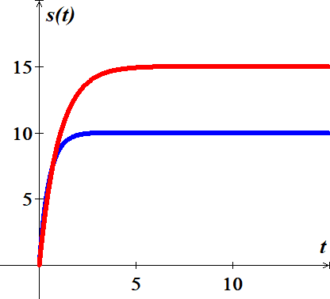 











1. 







The riders have the same position at the same time when 

1. From the graph, ***Mel*** takes the lead.